Steven Skinner

Module 9.2

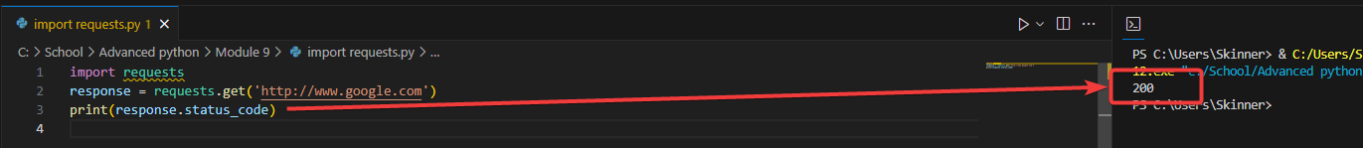

Actual API for astronauts

